KOREA INSTITUTE FOR INDUSTRIAL ECONOMICS AND TRADE (KIET)
Sejong, Republic of Korea
To: Gartner Global IP & Content Compliance (Attn: Ms. Sejal Kalra)
From: Heekwon Kyung and Sanghoon Kim (KIET)
Re: Content-compliance mock-up — Gartner-referencing excerpts, manuscript “When Technology Denial Binds: The Two Sources of Chokepoint Power” (International Organization submission). Case Ref #2025-139654
Date: 31 July 2026
Enclosure: This document (editable), 12 pp.: implementation summary and two confirmation requests; data-section excerpt; document-level attribution registry (Appendix I, Panels A–B); all fourteen Gartner-referencing figures as they appear; complete in-text mention inventory.

Content-Compliance Mock-up — Use of Gartner Research

1. Implementation of the three requirements, and two confirmation requests
(a) Complete citation: every cited Gartner document is referenced with its official title, in-file analyst byline, document number, and publication (deliverable-generation) date — registry in Appendix I. (b) Disclaimers: every author-drawn graphic based on Gartner research carries “Chart/Map created by the authors based on Gartner research … Calculations performed by the authors.” as printed in Section 4. (c) No commingling: source-separated graphics, demonstrated in Section 4. One note on the bracketed element in your disclaimer templates (“created by [KIET/Author Name]”): the manuscript’s as-printed phrasing is “created by the authors” / “performed by the authors,” because the journal’s double-blind review policy prohibits naming the authors in review copies. In the published version this resolves to “Heekwon Kyung and Sanghoon Kim (KIET)” wherever the named form is required — please confirm the anonymized phrasing is acceptable for the review-stage copies, with the named form in the published version.
Confirmation request 1 — author attribution (in-file bylines as the primary citation source). Every analyst byline in this mock-up is the verbatim “By …” line machine-extracted from the cited data deliverable’s own cover (Contents-sheet text box; legacy .xls: embedded cover text), corroborated where available by the public Gartner document pages. The 2021 Semiconductors edition’s byline (eighteen analysts) was read directly from the intact deliverable copy held in the authors’ licensed archive and cross-checked against the adjacent 2020 and 2022 in-file bylines and the era’s methodology bylines; the companion project’s inspection copy of the same deliverable is a drawing-stripped extract. Methodology companion documents are cited with their printed bylines (Appendix I, Panel B). Please confirm this satisfies the Author Name(s) requirement. The same convention is used in our parallel compliance case, for consistent adjudication.
Confirmation request 2 — no commingling. No graphic commingles Gartner data with content from any other source: Gartner-based panels and public-customs-data panels are drawn as separate graphics with independent source lines (demonstrated in Section 4), and the two theory schematics are data-free author illustrations. Please confirm this satisfies the requirement.

2. Data-section excerpt (as printed in the manuscript)
“…“…The argument is tested where denial actually operates — the firm × product × quarter level — on three proprietary Gartner market panels (devices, semiconductors, wafer-fabrication equipment) triangulated against public trade data, covering every major treated Chinese firm from the 2018 ZTE denial order to the 2022–24 equipment controls. Four identification designs discipline the narrative. A sanctioned-pair design compares Huawei to its untreated Chinese peers in ex-China markets, where the combined entity’s share fell 6.55 points under the Google-services ban and a further 11.66 under the chip ban (permutation p = .045–.050). A synthetic difference-in-differences design (Arkhangelsky et al. 2021) splits the same episode into its two chokepoints and returns the paper’s central fact: the software chokepoint froze the firm — share fell while volumes held (phase effect +2.2 percent) — and the hardware chokepoint destroyed it (−58.7 percent, placebo rank 1 of 23, p = .043; rank statistics are primary throughout). A staggered event study across designated firms delivers the conditional quartet — kill, stall, ignore, feed — that Section 3 predicts from barrier type: HiSilicon −84.5 percent; Phytium from +87 percent growth to −23.8; YMTC +218 percent straight through its designation; Cambricon +411 percent on the demand its adversary’s ban created. And an on/off natural experiment — ZTE, denied and then released in 2018 — shows the damage did not lift with the order (−33 percent against a flat pre-trend): policy is a switch, damage is a ratchet.…”…”

3. Appendix I — document-level attribution registry
Panel A — cited data deliverables (25 documents; verbatim in-file cover bylines, machine-extracted)
No abbreviation, reordering, or cross-channel substitution; independently cross-validated against public document pages and a second extraction pass (three-way cross-validation completed 31 July 2026; regression battery for the three known regex defect classes — colon variants, terminator truncation, Oxford comma — passed).
Cited document | Deliverable cover byline (verbatim, machine-extracted)
Semiconductors by End Market, 2016 | By Andrew Norwood, Nolan Reilly, Jon Erensen, Gerald Van Hoy, Adriana Blanco, George Brocklehurst, James Hines, Ben Lee, Bryan Lewis, Alan Priestley, Ganesh Ramamoorthy, Bill Ray, Roger Sheng, Hiroyuki Shimizu, Amy Teng, Joe Unsworth, Brady Wang, Claire Wen, Masatsune Yamaji
Semiconductors by End Market, 2017 | By Andrew Norwood, Nolan Reilly, Jon Erensen, George Brocklehurst, Ben Lee, Alan Priestley, Bill Ray, Roger Sheng, Amy Teng, Joe Unsworth, Brady Wang, Claire Wen, Masatsune Yamaji
Semiconductors by End Market, 2018 | By Andrew Norwood, Nolan Reilly, Jon Erensen, George Brocklehurst, Ben Lee, Alan Priestley, Bill Ray, Roger Sheng, Amy Teng, Joe Unsworth, Claire Wen, Masatsune Yamaji, Nitu Uppal, Juhi Gupta, Anushree Verma
Semiconductors by End Market, 2019 | By Andrew Norwood, Jon Erensen, George Brocklehurst, Ben Lee, Alan Priestley, Bill Ray, Roger Sheng, Amy Teng, Joseph Unsworth, Masatsune Yamaji, Juhi Gupta, Anushree Verma, Rajeev Rajput, Kanishka Chauhan, Nolan Reilly
Semiconductors by End Market, 2020 | By Andrew Norwood, Jon Erensen, George Brocklehurst, Ben Lee, Alan Priestley, Bill Ray, Roger Sheng, Amy Teng, Joseph Unsworth, Masatsune Yamaji, Juhi Gupta, Anushree Verma, Rajeev Rajput, Kanishka Chauhan, Nikita Singh, Nolan Reilly
Semiconductors by End Market, 2021 | By Andrew Norwood, Kanishka Chauhan, Jon Erensen, Juhi Gupta, Ben Lee, Tim Mahon, Alan Priestley, Rashi Priyam, Rajeev Rajput, Bill Ray, Nolan Reilly, Roger Sheng, Nikita Singh, Sridhar Srinivasan, Joseph Unsworth, Anushree Verma, Masatsune Yamaji, and Stacey Yin
Semiconductors by End Market, 2022 | By Andrew Norwood, Ben Lee, Nolan Reilly, Jon Erensen, Joseph Unsworth, Tim Mahon, Roger Sheng, Anushree Verma, Bill Ray, Kanishka Chauhan, Nikita Singh, Stacey Yin, Sridhar Srinivasan, Shrish Pant, Tushar Gupta, Jainendra Singh, Kartikay Gulani, Richard Gordon, Rajeev Rajput, Alan Priestley, Masatsune Yamaji
Semiconductors by End Market, 2023 | By Rajeev Rajput, Alan Priestley, Anushree Verma, Bill Ray, Ben Lee, Joseph Unsworth, Jon Erensen, Kanishka Chauhan, Masatsune Yamaji, Nikita Singh, Roger Sheng, Shrish Pant, Stacey Yin, Jainendra Singh, Kartikay Gulani, Yashika Goyal and Tim Mahon
Semiconductors by End Market, 2024 | By Rajeev Rajput, Anushree Verma, Ben Lee, Guy Robertson, Himanshu Kumar Ojha, Jainendra Singh, Jon Erensen, Joseph Unsworth, Kanishka Chauhan, Kartikay Gulani, Masatsune Yamaji, Menglin Cao, Roger Sheng, Shrish Pant, Stacey Yin and Yashika Goyal
Semiconductors by End Market, 2025 | By Rajeev Rajput, Ben Lee, Guy Robertson, Jainendra Singh, Joseph Unsworth, Jon Erensen, Kartikay Gulani, Masatsune Yamaji, Menglin Cao, Roger Sheng, Shrish Pant, Warren Peng and Yashika Goyal
Wafer Fab Equipment, 2017 | By Bob Johnson and Gaurav Gupta
Wafer Fab Equipment, 2018 | By Bob Johnson and Gaurav Gupta
Wafer Fab Equipment, 2019 | By Bob Johnson and Gaurav Gupta
Wafer Fab Equipment, 2020 | By Bob Johnson and Gaurav Gupta
Wafer Fab Equipment, 2021 | By Bob Johnson and Gaurav Gupta
Wafer Fab Equipment, 2022 | By Bob Johnson, Gaurav Gupta, Menglin Cao
Wafer Fab Equipment, 2023 | By Bob Johnson, Gaurav Gupta and Menglin Cao
Wafer Fab Equipment, 2024 | By Bob Johnson and Menglin Cao
Wafer Fab Equipment, 2025 | By Menglin Cao and Bob Johnson
PCs/Devices, 4Q18 Update | By Mikako Kitagawa, Anshul Gupta, Roberta Cozza, Ranjit Atwal, David Glenn, Kanae Maita, Meike Escherich, Annette Jump, Lillian Tay, Tuong Huy Nguyen, Bruno Lakehal, Annette Zimmermann and CK Lu
PCs/Devices, 4Q20 Update | By Mikako Kitagawa, Anshul Gupta, Roberta Cozza, Ranjit Atwal, Annette Jump, Tuong Huy Nguyen, Bruno Lakehal, Annette Zimmermann, CK Lu, Tracy Tsai, Namrata Banerjee and Rishi Padhi
PCs/Devices, 4Q21 Update | By Mikako Kitagawa, Anshul Gupta, Roberta Cozza, Ranjit Atwal, Annette Jump, Tuong Huy Nguyen, Annette Zimmermann, Tracy Tsai, Namrata Banerjee and Rishi Padhi
PCs/Devices, 4Q22 Update | By Mikako Kitagawa, Anshul Gupta, Roberta Cozza, Ranjit Atwal, Annette Zimmermann, Tracy Tsai, Namrata Banerjee, Rishi Padhi and Rounak Bhattacharyya
PCs/Devices, 4Q23 Update | By Rishi Padhi, Mikako Kitagawa, Roberta Cozza, Ranjit Atwal, Tracy Tsai, Anshul Gupta, Roger Sheng, Namrata Banerjee, Rounak Bhattacharyya and Divyanshu Singh
PCs/Devices, 4Q25 Update | By Namrata Banerjee, Rishi Padhi, Rounak Bhattacharyya, Divyanshu Singh and Roger Sheng
Panel B — methodology companion documents (printed bylines, from the documents themselves)
Market Definitions and Methodology — Semiconductor series
Document ID | Published | Printed byline
G00322482 | 2017-01-23 | Gerald Van Hoy, Bryan Lewis, Ben Lee, James F. Hines, Hiroyuki Shimizu, Adriana Blanco, Andrew Norwood, Amy Teng, Jon Erensen, Joseph Unsworth, Masatsune Yamaji, Ganesh Ramamoorthy, Brady Wang, Michele Reitz, Roger Sheng, Claire Wen, Alan Priestley, George Brocklehurst
G00332428 | 2017-10-30 | George Brocklehurst, Bryan Lewis, Ben Lee, Adriana Blanco, Andrew Norwood, Amy Teng, Jon Erensen, Joseph Unsworth, Masatsune Yamaji, Ganesh Ramamoorthy, Brady Wang, Roger Sheng, Claire Wen, Alan Priestley
G00351311 | **2018-03-12** (★정정: 구판 2019-04-09는 파일명 유래 오기) | Gaurav Gupta, Bill Ray, Joseph Unsworth, Andrew Norwood, Claire Wen, Alan Priestley, Roger Sheng, Brady Wang, Masatsune Yamaji, Jon Erensen, Amy Teng, Ben Lee, George Brocklehurst
G00450878 | 2019-09-27 | Andrew Norwood, Ben Lee, Amy Teng, Jon Erensen, Joseph Unsworth, Masatsune Yamaji, Roger Sheng, Claire Wen, Bill Ray, Alan Priestley, George Brocklehurst, Anushree Verma
G00725129 | 2020-06-15 | Andrew Norwood, Ben Lee, Anushree Verma, Masatsune Yamaji
G00742987 | 2021-06-15 | Andrew Norwood, Ben Lee, Anushree Verma, Masatsune Yamaji
G00771905 | 2022-08-25 | Andrew Norwood, Ben Lee, Masatsune Yamaji, Rajeev Rajput, Kanishka Chauhan
G00794258 | 2023-07-17 | Rajeev Rajput, Masatsune Yamaji, Ben Lee, Roger Sheng, Jon Erensen, Andrew Norwood
G00809421 | 2024-07-25 | Rajeev Rajput, Alan Priestley, Kanishka Chauhan, Masatsune Yamaji
G00831545 | 2025-07-02 | Rajeev Rajput, Jainendra Singh, Jon Erensen, Joseph Unsworth, Masatsune Yamaji, Menglin Cao, Roger Sheng, Shrish Pant
G00849046 | 2026-03-09 | Rajeev Rajput
Wafer Fab Equipment series
Document ID | Published | Printed byline
G00725127 | 2020-06-10 | Bob Johnson, Gaurav Gupta
G00745198 | 2021-06-15 | Bob Johnson, Gaurav Gupta
G00765289 | 2022-06-27 | Menglin Cao, Gaurav Gupta, Bob Johnson
G00794257 | 2023-07-20 | Menglin Cao, Bob Johnson, Gaurav Gupta
G00827116 | 2025-02-25 | Menglin Cao, Bob Johnson
G00831546 | 2025-07-01 | Menglin Cao, Bob Johnson
G00848990 | 2026-03-10 | Menglin Cao, Bob Johnson
Devices (PCs, Tablets and Mobile Phones) series
Document ID | Published | Printed byline
G00323989 | **2017-02-17** (★정정: 구판 2017-12-01은 파일명 유래 오기) | Annette Zimmermann, Meike Escherich
G00463636 | 2019-12-09 | Ranjit Atwal, Rishi Padhi, Namrata Banerjee
G00743549 | 2021-06-18 | Ranjit Atwal
G00770610 | 2022-10-04 | Ranjit Atwal
G00794013 | 2023-08-23 | Ranjit Atwal
G00815321 | 2024-07-02 | Ranjit Atwal
G00849005 | 2026-03-23 | Rishi Padhi

4. All Gartner-referencing figures, as printed (incl. source-separation demonstration)
Figure 1(i) —The dual image in the vendor panels.

Notes: Panel A, the failure narrative — Chinese brands’ world smartphone share (canonical 20-brand set) rose from 31.6% in 2016 to 46.7% through every sanction, with PCs on the same path. Panel B, the success narrative — HiSilicon’s world share collapsed 1.89 → 0.22% in the middle of the 2021 boom, with a partial revival capped by the domestic-7nm ceiling. Shaded band marks the maximum-effort era (May 2019 Entity List → 2025). analysts and publication dates listed in the reference list [analyst names to be completed]. Calculations performed by the authors.
Figure 2 —One control regime, four responses: prediction, case, and data.

Notes: Main panels = observed log revenue; insets = the stylized prediction for each response type; boxes = case, repro-canonical result, and identification design. Chart created by the authors based on Gartner research. Source: .
Figure 3 —The moat cuts both ways.
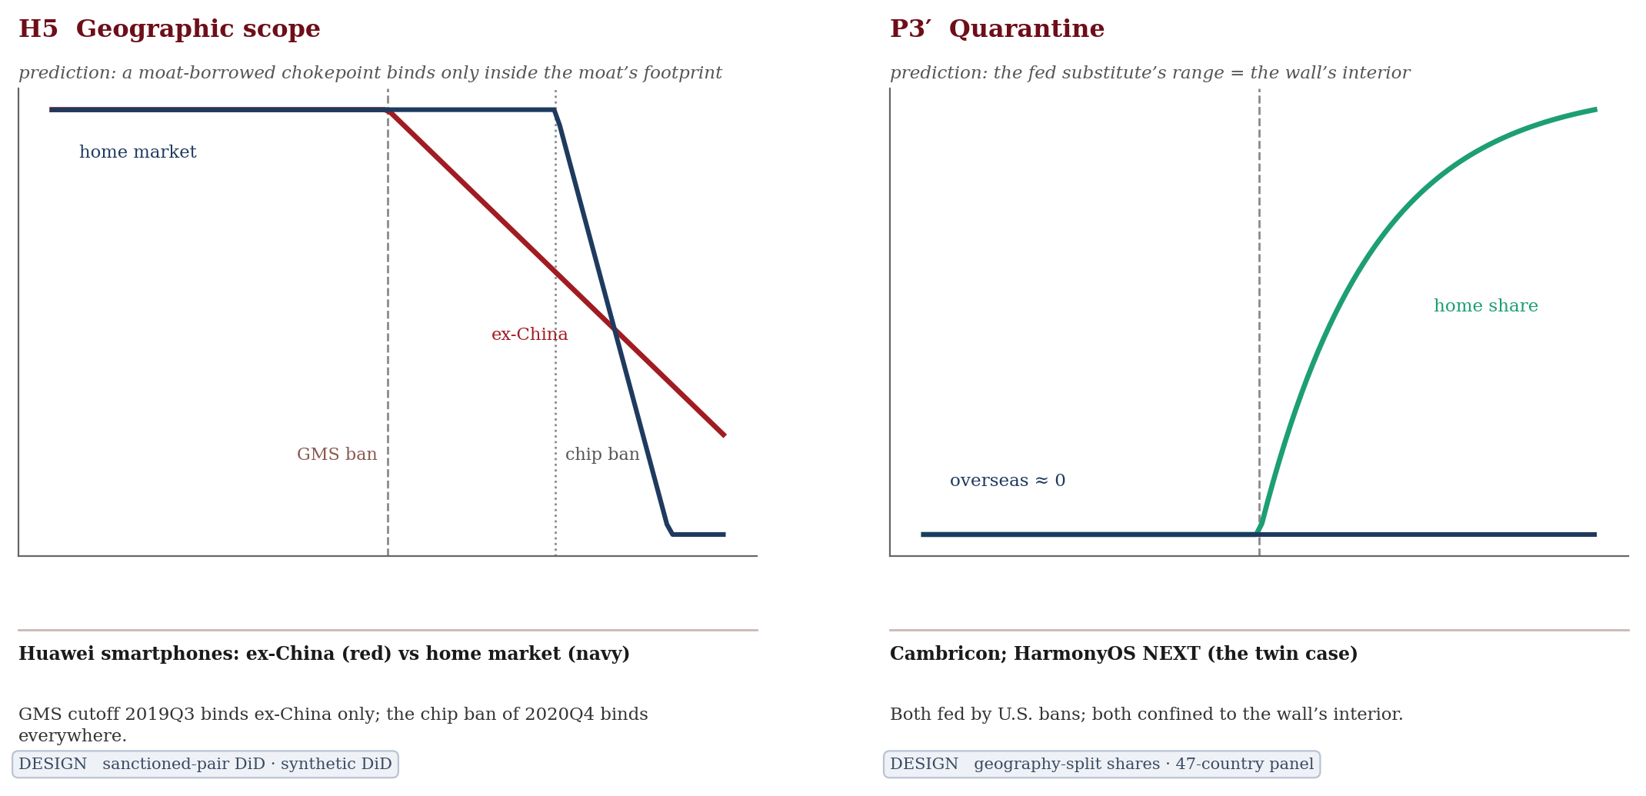
Notes: Outward scope (H5: Huawei, two chokepoints, two geographies) and inward quarantine (P3′: Cambricon & HarmonyOS, fed at home, ≈0 abroad). Empirical results (moved from the in-figure cards): Huawei ex-China share −6.55 pp (perm p=.045–.050); volume: GMS ≈0 vs chip −58.7% — froze, then destroyed; home held until chips. Cambricon overseas ≈0; 0.34% of global compute. HarmonyOS: China 4.1% (25Q4), abroad 0.000% across 46 markets. Illustration created by the authors; the empirical results in these notes are computed by the authors from Gartner research and CEPII BACI data (see reference list).
Figure 4 —Time asymmetry and feedback.
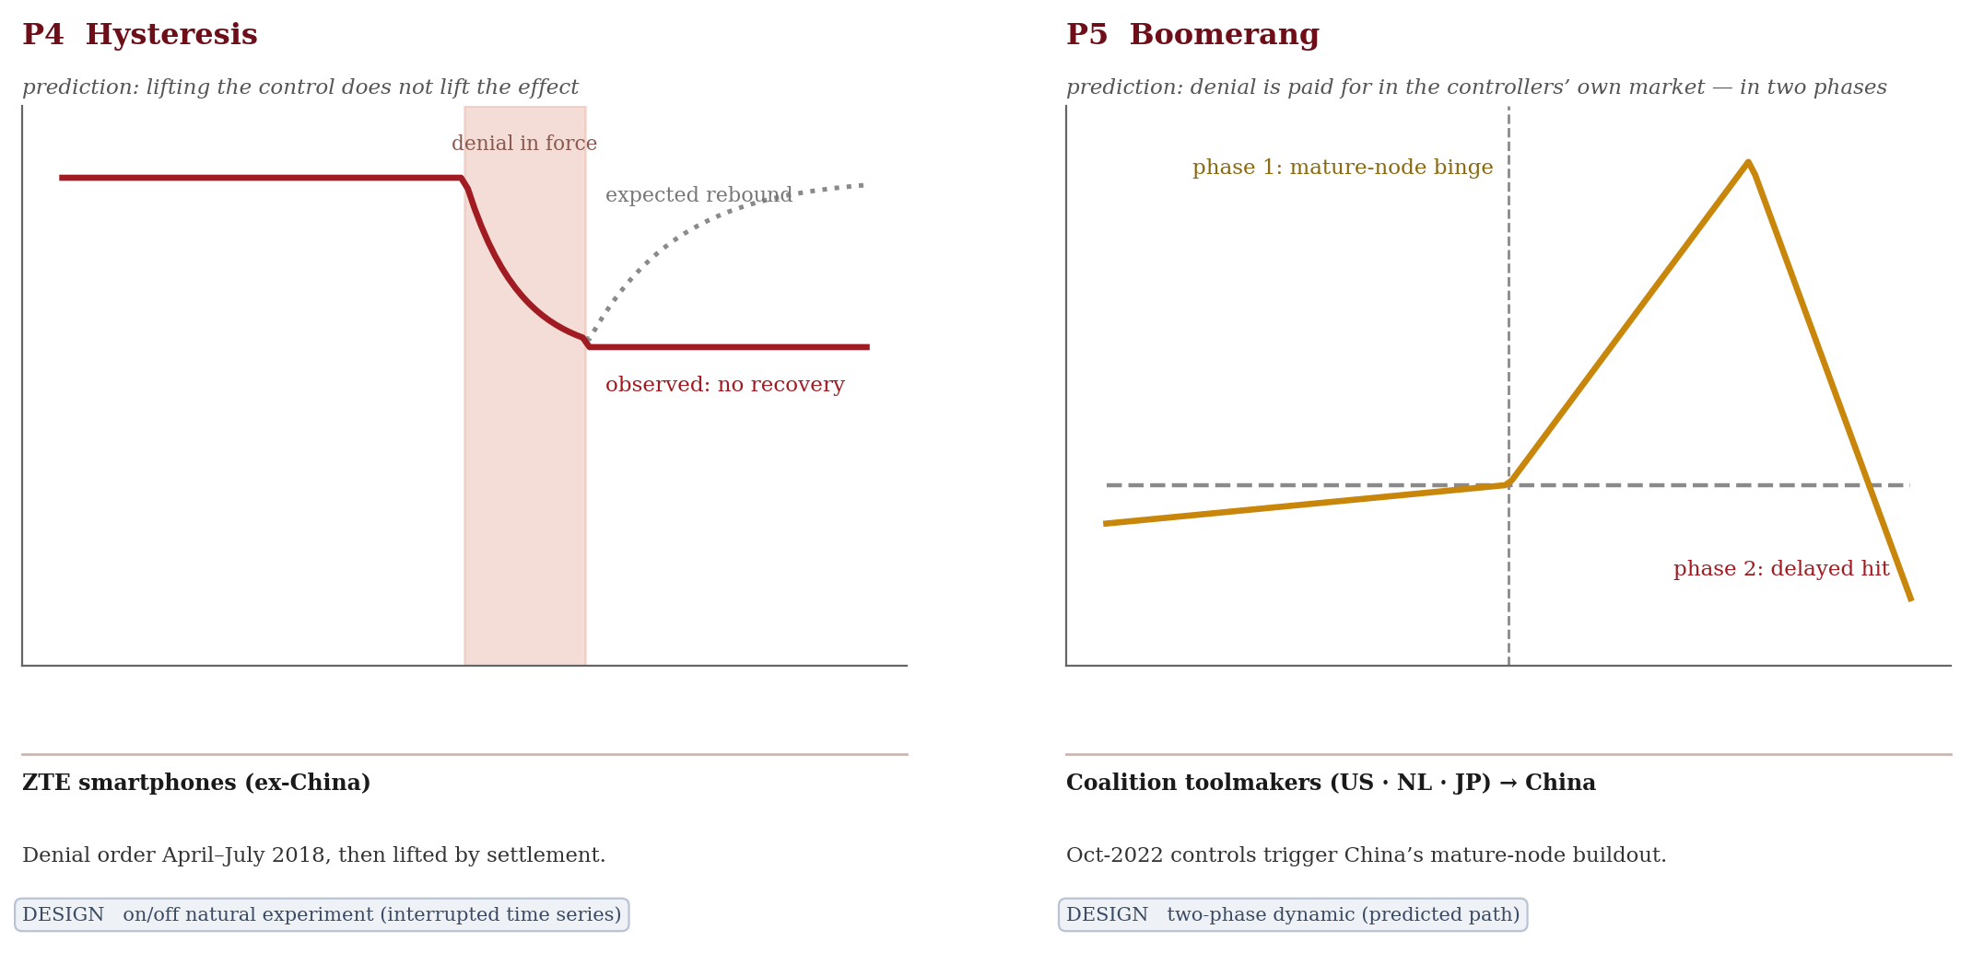
Notes: Hysteresis (P4: ZTE, lifted but not recovered) and the two-phase boomerang (P5: coalition toolmakers). Empirical results (moved from the in-figure cards): ZTE 2019 average −33% vs a flat pre-trend, no recovery after the order was lifted. Coalition→China core-tool exports +95% to a record $22.9 bn (2024); Chinese toolmakers +3.55 pp in crackable segments (p=.040; trend-adj. +2.27, p=.119); lithography 0. Illustration created by the authors; the empirical results in these notes are computed by the authors from Gartner research and CEPII BACI data (see reference list).
Figure 5 —The sanctioned-pair design: Huawei, untreated peers, and the Honor divestiture (ex-China).
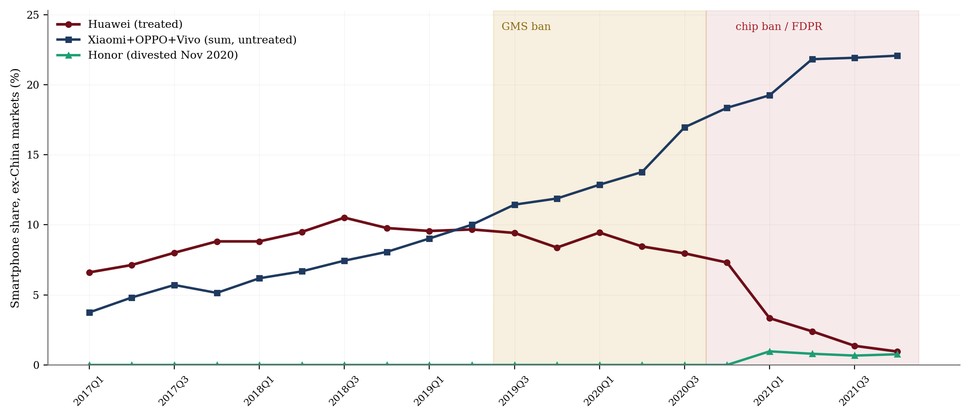
Notes: DiD: shares peer-sum −6.55/−11.66 pp (perm p=.043–.048); SDID chip adoption −58.7% (p=.043). .(analysts listed on the Gartner document page; see reference list). Calculations performed by the authors.
Figure 6 —Synthetic difference-in-differences: froze, then destroyed.
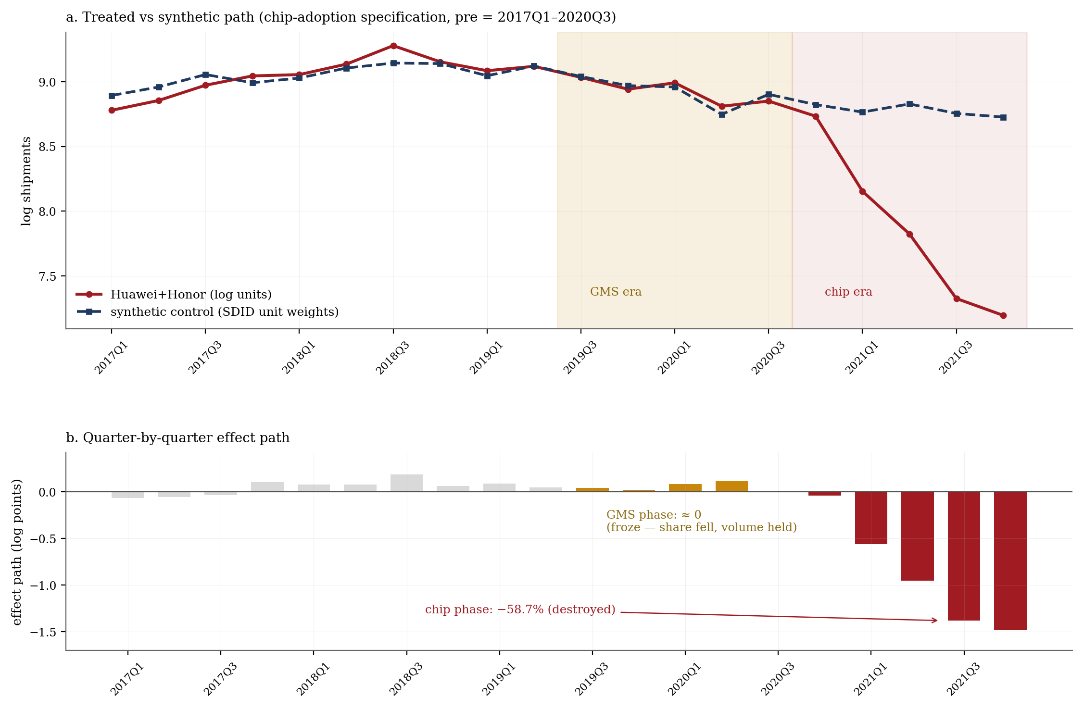
Notes: Top — treated vs synthetic path (chip-adoption spec, pre = 2017Q1–2020Q3). Bottom — quarterly effect path: GMS-era ≈ 0 (regime-spec phase +2.2%), chip era −58.7% (τ, placebo rank 1/23 p=.043; size-matched 1/13; regime-spec chip phase −60.2%; M̄* = 2.2). Chart created by the authors based on Gartner research.
Figure 7 —The last wall: U.S. operating systems hold every market on Earth.

Notes: The sole crack sits behind China’s own firewall. Color depth = Android+iOS share; red outline marks the sole breach. No market falls below 96.6% (full-year 2025; China in 25Q4: 95.9%). Map created by the authors based on Gartner research. Source:
Figure 8 —The ZTE test: lifting the control did not lift the effect.

Notes: Flat pre-trend; −33% persists after the July 2018 settlement. . .
Figure 9 —The Kirin discontinuity: the engine builds, the decree destroys, the substitute partially revives.

Notes: Chinese vendors’ share of worldwide integrated baseband/application processor revenue. Series shown from 2016; Gartner’s vendor attribution for this category begins in the mid-2010s, so earlier zeros reflect attribution coverage, not absence. . Chart created by the authors based on Gartner research.
Figure A4 —The segment anatomy of the feed.
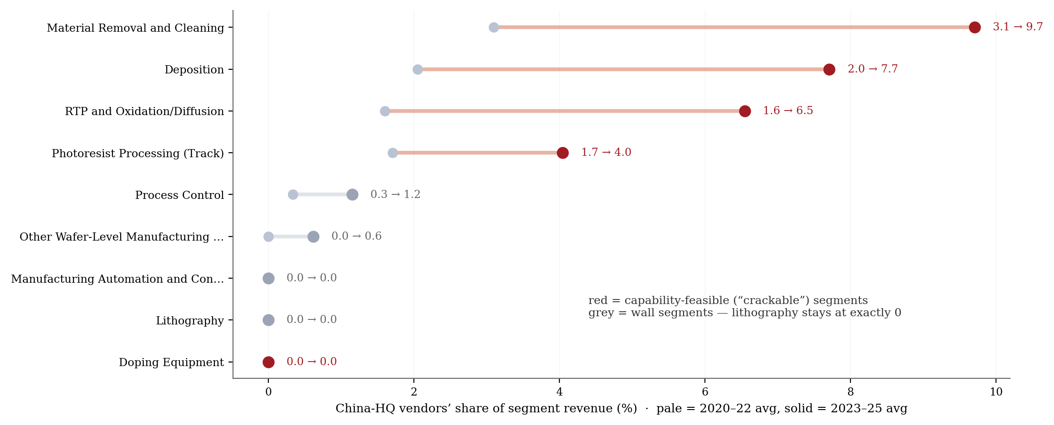
Notes: Crackable segments rise (+3.55 pp, benchmark p=.040; trend-adjusted +2.27, p=.119 — an acceleration pattern), lithography exactly 0 → 0. Chart created by the authors based on Gartner research
Figure A5 —Placebo inference for the synthetic DiD.
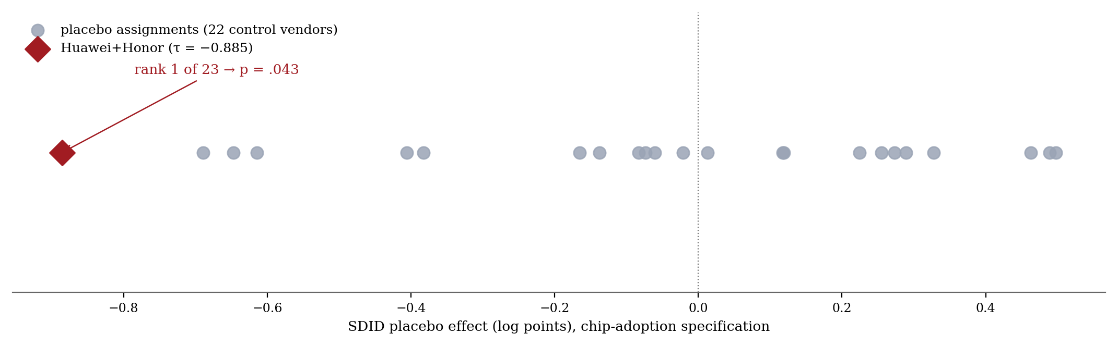
Notes: The treated unit is the most extreme of 23 assignments (p=.043; size-matched pool 1/13, p=.077). Rank statistics primary (cross-unit heteroskedasticity).
Figure A6 —Cycle-adjusted event histories.
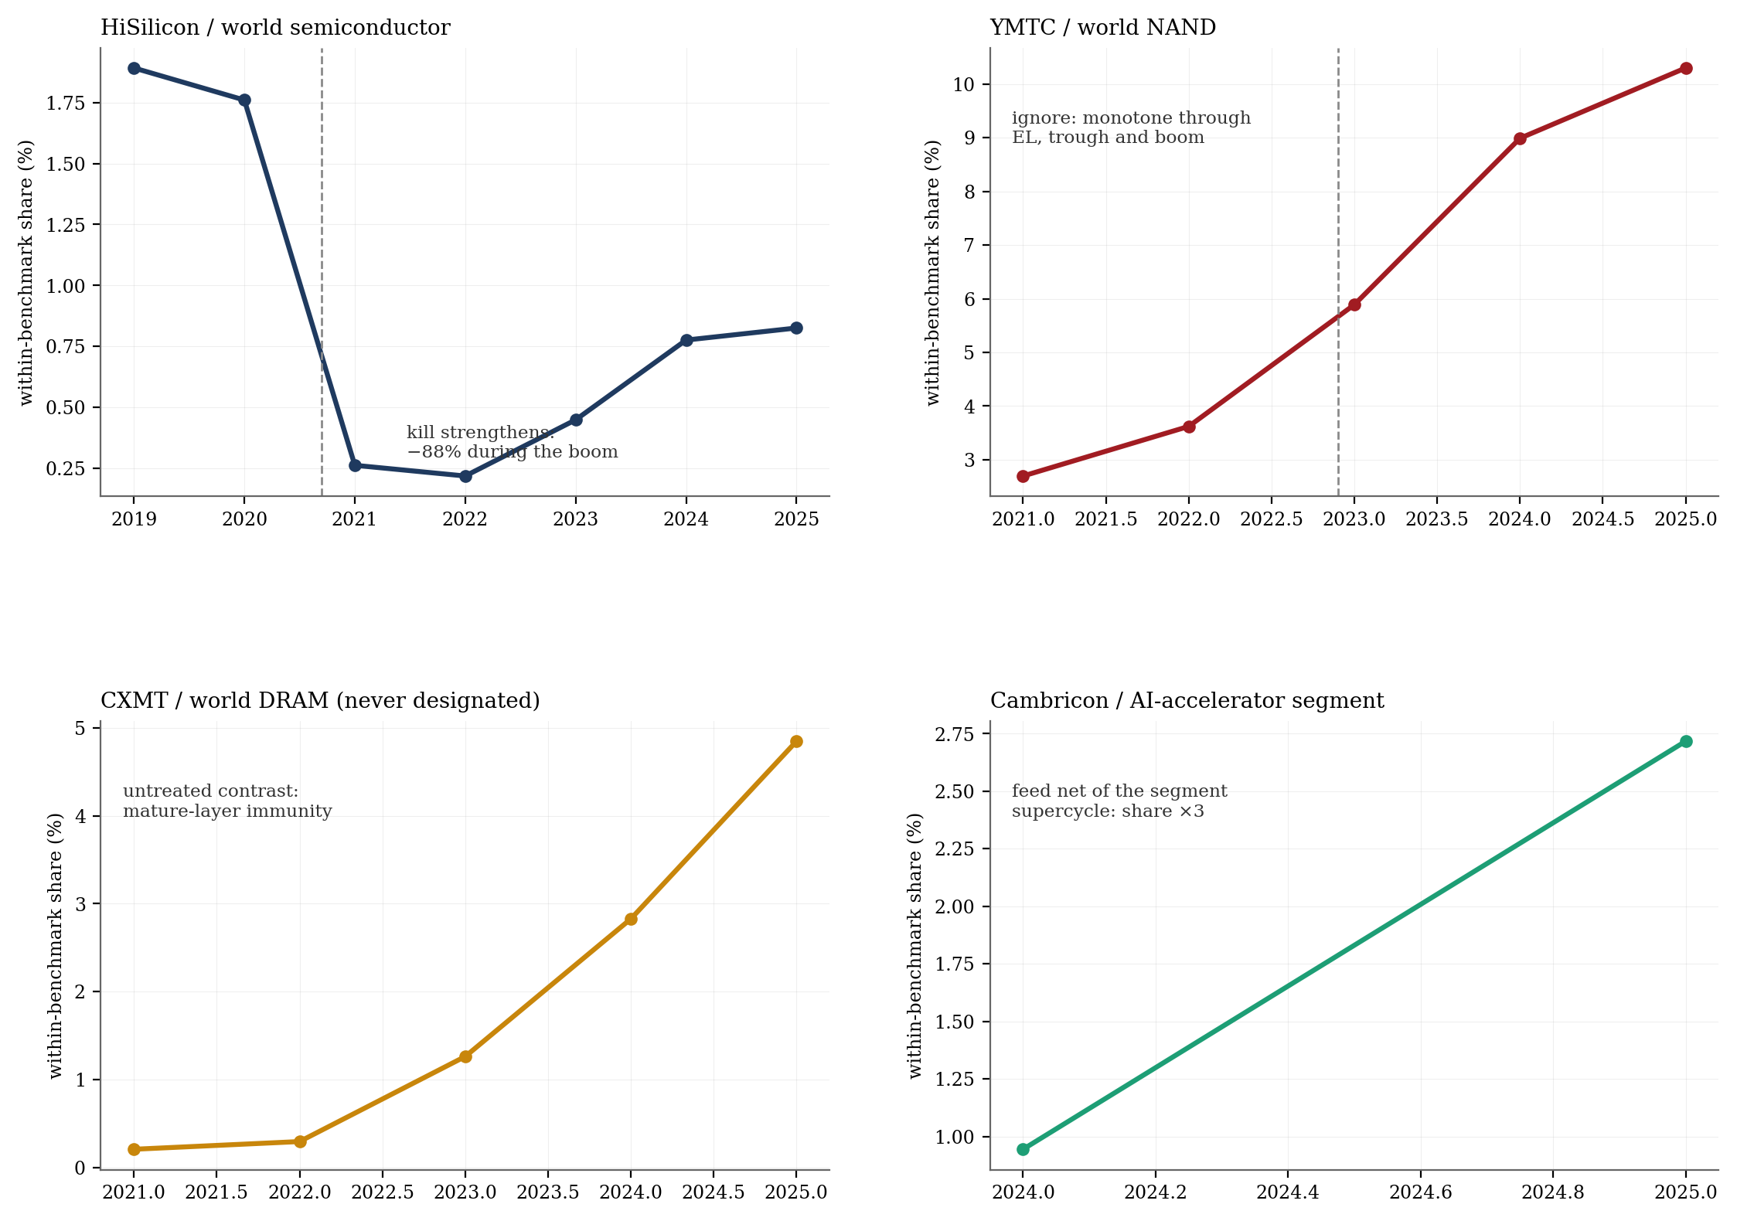
Notes: Within-segment shares difference out the COVID boom → 2023 trough → AI supercycle. Kill strengthens; stall and ignore are robust; feed decomposes.
Figure A7 —The ladder, 2019 → 2025: what moved and what froze.
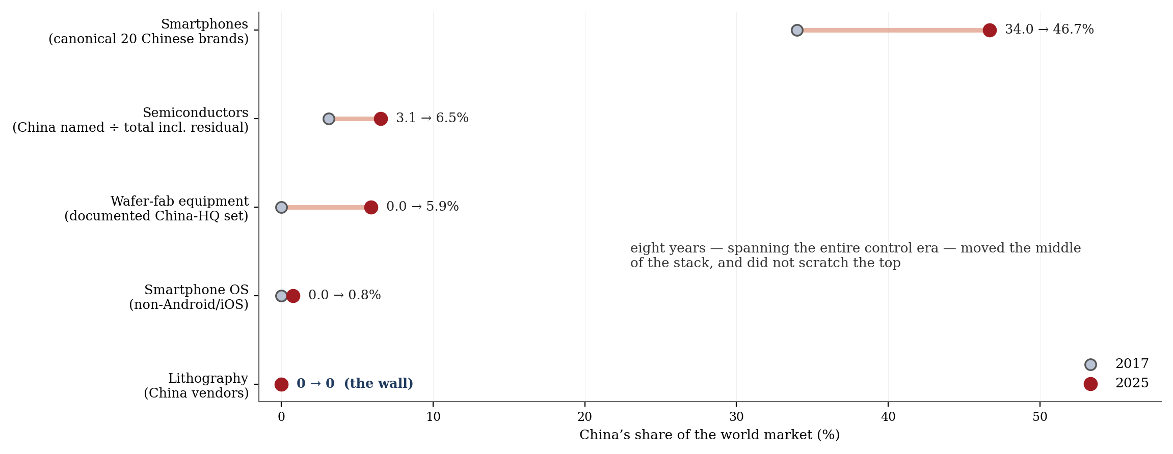
Notes: Six years of maximum effort moved the middle of the stack (devices +18 pp, WFE +5.5 pp on shared-anchor conventions) and did not scratch the top (OS 0.76%, lithography 0 → 0).
Figure 1(ii) —The dual image in the customs ledger.
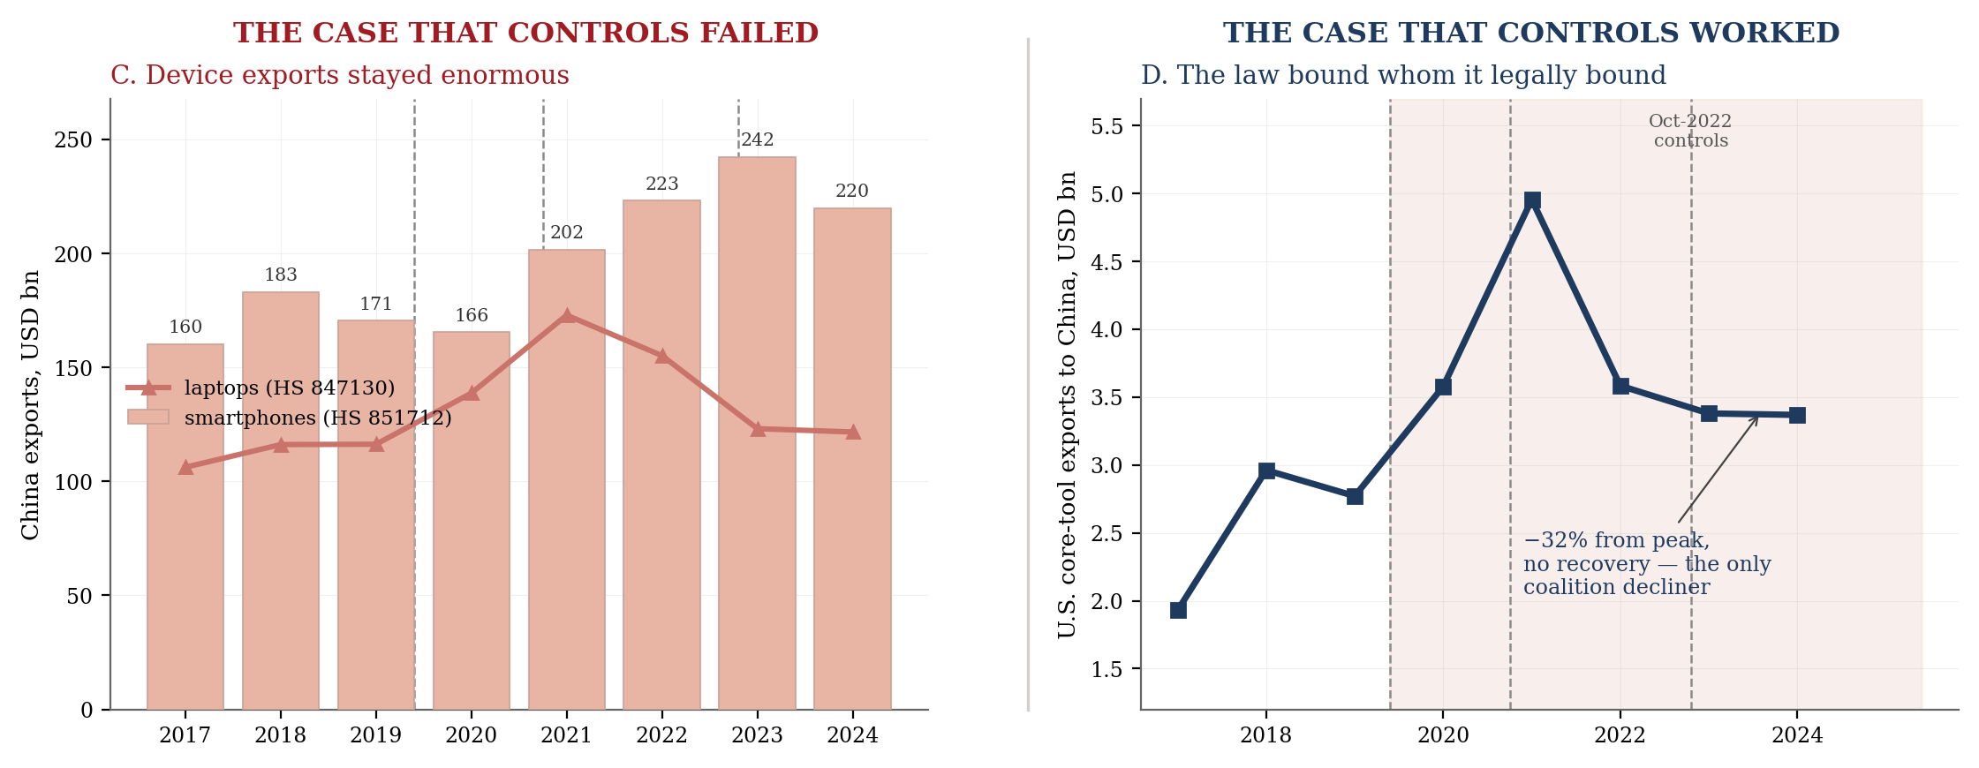
Notes: The same dual image, drawn from an independent measurement system. Panel C — China’s device exports held at $160–242 bn per year (smartphones, HS 851712) with laptops on a parallel path. Panel D — U.S. core-tool exports to China fell 32% from peak and never recovered, the only coalition decliner. Source: CEPII BACI V202601 (Gaulier and Zignago 2010), harmonized mirror-adjusted trade flows; series end in 2024, the last BACI year. Calculations performed by the authors.

5. In-text inventory (all body passages referencing Gartner)
“…“…The argument is tested where denial actually operates — the firm × product × quarter level — on three proprietary Gartner market panels (devices, semiconductors, wafer-fabrication equipment) triangulated against public trade data, covering every major treated Chinese firm from the 2018 ZTE denial order to the 2022–24 equipment controls. Four identification designs discipline the narrative. A sanctioned-pair design compares Huawei to its untreated Chinese peers in ex-China markets, where the combined entity’s share fell 6.55 points under the Google-services ban and a further 11.66 under the chip ban (permutation p = .045–.050). A synthetic difference-in-differences design (Arkhangelsky et al. 2021) splits the same episode into its two chokepoints and returns the paper’s central fact: the software chokepoint froze the firm — share fell while volumes held (phase effect +2.2 percent) — and the hardware chokepoint destroyed it (−58.7 percent, placebo rank 1 of 23, p = .043; rank statistics are primary throughout). A staggered event study across designated firms delivers the conditional quartet — kill, stall, ignore, feed — that Section 3 predicts from barrier type: HiSilicon −84.5 percent; Phytium from +87 percent growth to −23.8; YMTC +218 percent straight through its designation; Cambricon +411 percent on the demand its adversary’s ban created. And an on/off natural experiment — ZTE, denied and then released in 2018 — shows the damage did not lift with the order (−33 percent against a flat pre-trend): policy is a switch, damage is a ratchet.…”…”
“…“…The argument is tested where denial actually operates — the firm × product × quarter level — on three proprietary Gartner market panels (devices, semiconductors, wafer-fabrication equipment) triangulated against public trade data, covering every major treated Chinese firm from the 2018 ZTE denial order to the 2022–24 equipment controls. Four identification designs discipline the narrative. A sanctioned-pair design compares Huawei to its untreated Chinese peers in ex-China markets, where the combined entity’s share fell 6.55 points under the Google-services ban and a further 11.66 under the chip ban (permutation p = .045–.050). A synthetic difference-in-differences design (Arkhangelsky et al. 2021) splits the same episode into its two chokepoints and returns the paper’s central fact: the software chokepoint froze the firm — share fell while volumes held (phase effect +2.2 percent) — and the hardware chokepoint destroyed it (−58.7 percent, placebo rank 1 of 23, p = .043; rank statistics are primary throughout). A staggered event study across designated firms delivers the conditional quartet — kill, stall, ignore, feed — that Section 3 predicts from barrier type: HiSilicon −84.5 percent; Phytium from +87 percent growth to −23.8; YMTC +218 percent straight through its designation; Cambricon +411 percent on the demand its adversary’s ban created. And an on/off natural experiment — ZTE, denied and then released in 2018 — shows the damage did not lift with the order (−33 percent against a flat pre-trend): policy is a switch, damage is a ratchet.…”…”
“…“…The evidence comes from three subscription market-research panels produced by Gartner (Gartner 2026a, 2026b, 2026c) — for devices, semiconductors, and wafer-fabrication equipment — reported here at their native resolution and with their nature stated plainly: they are vendor estimates, not audited accounts, and are treated as such. The devices panel resolves to the vendor × quarter × country level across 47 countries, which is what makes the geographic tests of Section 6 possible; the semiconductor and equipment panels resolve to vendor × segment × year. Throughout, China-headquartered vendors are identified on a strict ownership basis — a classification that matters at the margin, and one that excludes, for instance, SMIT, an ion-implantation maker owned by Sumitomo and therefore Japanese despite operating in China — and every share is reported on an explicit denominator, named vendors against a total that either includes or excludes the unnamed residual, stated in each case.…”…”
“…“…Three disclosures complete the design. First, the specification hierarchy is stated in advance to preempt any suspicion of estimate-shopping: the share difference-in-differences (clean on pre-trends) and the synthetic difference-in-differences (robust to pre-trends) are co-primary and answer different questions; the naive volume ranges are context, not headline; and the synthetic-control bound is reported as a bound and never as a point estimate. Second, a boundary disclosure on the two-chokepoint decomposition: the later quarters mix the exhaustion of stockpiled chips with the expiry of the last Google-certified model pipeline, so the chip-adoption estimate is properly read as a regime-intensification effect, and because its pre-period includes Google-services-era quarters in which the volume phase path is approximately zero, any residual services-era volume effect biases the chip estimate toward zero — a conservative direction. Third, replication: the derived share tables and full analysis code are deposited in the journal’s Dataverse, with the scope of what the Gartner license permits to be confirmed at submission. The reproducibility architecture is described in the appendix.…”…”
“…“…The derived share tables, all analysis code, and the full verification architecture — including a line-by-line numeric audit that re-derives every figure reported in the text from the raw sources — will be deposited in the journal’s Dataverse upon acceptance. The underlying Gartner market panels are proprietary and were used under license; the scope of what may be redistributed is confirmed with Gartner at submission, and the replication package is designed so that every result can be verified against the licensed originals by any subscriber. The CEPII BACI trade data (V202601) are publicly available from CEPII.…”…”
“…“…Gartner. 2026a. Market Share: PCs, Tablets and Mobile Phones Including ASP, Worldwide, 4Q25 Update. February 2026. Stamford, CT: Gartner, Inc. By Namrata Banerjee, Rishi Padhi, Rounak Bhattacharyya, Divyanshu Singh and Roger Sheng (deliverable cover byline; generated 26 February 2026). Prior quarterly editions 2014–2025 cited at the vintage level, including PCs, Ultramobiles and Mobile Phones, All Countries, 4Q21 Update (18 February 2022).…”…”
“…“…Gartner. 2026b. Market Share: Semiconductor Wafer Fab Equipment, Worldwide, 2025. 2026. Stamford, CT: Gartner, Inc. By Menglin Cao and Bob Johnson (deliverable cover byline; generated 30 March 2026). Prior annual editions 2011–2024 cited at the vintage level.…”…”
“…“…Gartner. 2026c. Market Share: Semiconductors by End Market, Worldwide, 2025. 2026. Stamford, CT: Gartner, Inc. By Rajeev Rajput, Ben Lee, Guy Robertson, Jainendra Singh, Joseph Unsworth, Jon Erensen, Kartikay Gulani, Masatsune Yamaji, Menglin Cao, Roger Sheng, Shrish Pant, Warren Peng and Yashika Goyal (deliverable cover byline, workbook 846653). Prior annual editions cited at the vintage level (published as Semiconductor Applications through 2014 and Semiconductor Devices and Applications through 2017).…”…”

